Create a web app.

First page: contains list of all games below like the following with time.

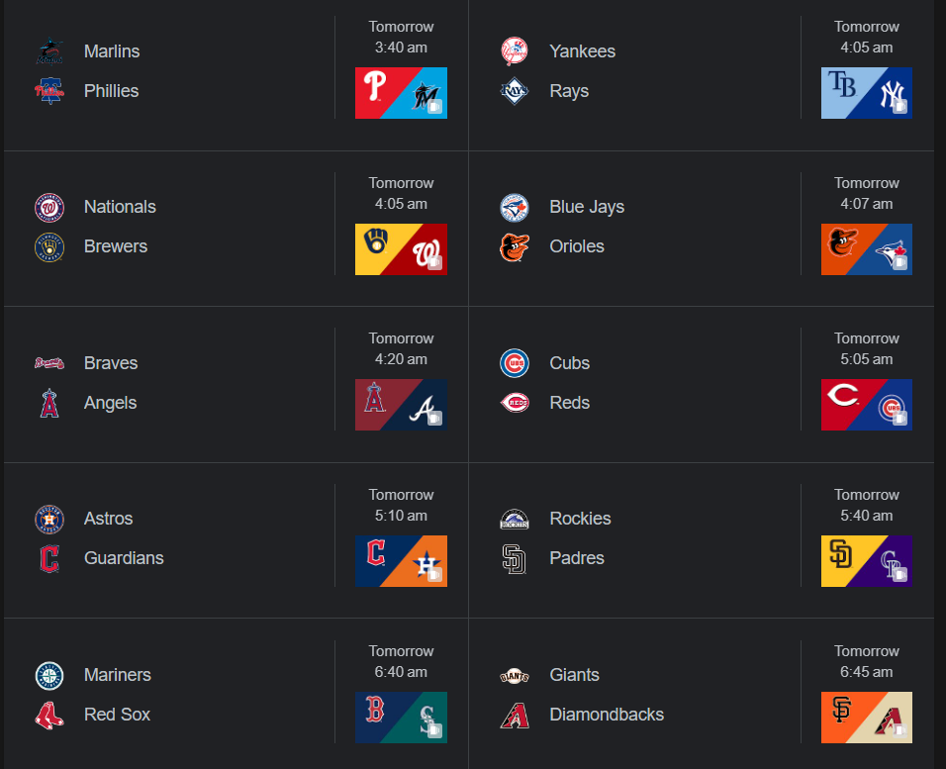

Once you select a match from one of the above it opens a webpage like:   
  
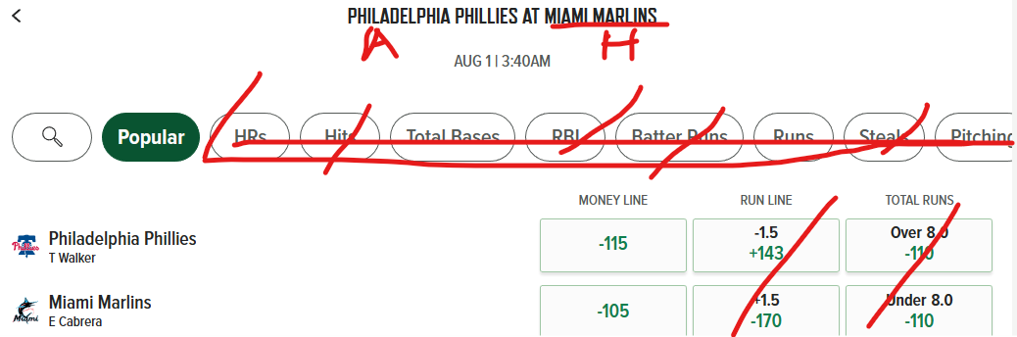

A and H are for Home and Away.

Show only the Money line. Make it interactive.